

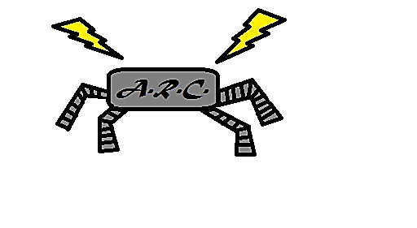

Team A.R.C. - Project Plan

***Team Members***:

Logan Beaver

Justin Campbell

Tyler Paddock

Ronald Shipman

***Advisor***: Dr. Luis A. Rodriguez

|  |  |
| --- | --- |
| Milwaukee School of Engineering | Mechanical Engineering Senior Design |